Challenge X 2007

Outreach Program Report # 2

Team: University of Tulsa

Name of Outreach Coordinator: Melissa Young

Phone number and email of Coordinator: (918) 706-1635; Melissa-young@utulsa.edu

Dedicated Outreach Coordinator (Y/N): Yes

If no, please list other role the O.C. has on your team:

Date posted: March 29th, 2007

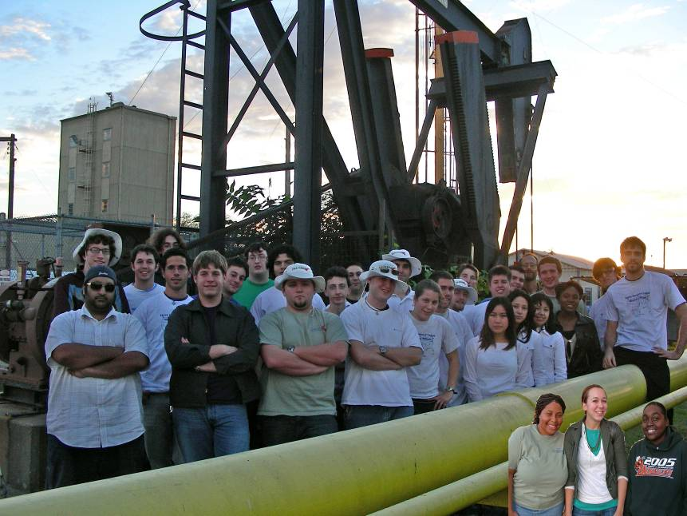

I. Outreach Plan

Media Relations: No Changes

Youth Events: On March 30th, there will be an event for 6th-12th grade with an expectancy of 200-300 students. Also on March 30th, we will have approximately 20 high school girls on TU’s North Campus to tour the car and learn about the project.

Community Events: No Changes

Sponsor Events: No Changes

Website: Soon to be updated is a game for High School students to be available on the main site.

II. Outreach Activity Detail

- Media Relations (Requirement of 5 media hits)
Please list each media hit or event since your last outreach report. Please number your events below. Please provide copies of any media clips in the Appendix.

Media Type | Media Outlet and Reporter’s Name | Date | Location | Coverage Origin

- Youth Outreach (Requirement of 3 events)
Please use the chart to provide a list of all of your youth outreach activities since your last outreach report. Also provide a written description below with additional details for each youth outreach activity listed. Please number your events below.

Activity | Date | Location | Audience | Participants
1. Girl Scout Brownie Day | February 10th, 2007 | Tulsa, Oklahoma | 1st-3rd grade Girl Scouts, approx. 100 girls | Outreach Cooridinator, Melissa Young, Team Leader, Joshue Buck, Outreach Team, Sabrina Jones, Courtney Palmer, and team member Andrew Harmon
2. Middle School Open House | February 21st, 2007 | Tulsa, Oklahoma | Approx. 100 middle school aged children | Outreach Coordinator, Melissa Young, Team members Clara Seaman and Michael Kennedy
3. Girl Scout Badge Day | February 24th, 2007 | Tulsa, Oklahoma | Middle school Girl Scouts, approx. 20 | Team Leader, Josh Buck, Faculty Advisor Dr. Christi Patton, Outreach Coordinator Melissa Young

1. Youth activity name: Girl Scout Brownie Day Date/Time: 2/10/07 10a-2p
Location: Main Engineering Hall, University of Tulsa, Tulsa, OK
Team participants: Team Leader Joshua Buck, Outreach Coordinator Melissa Young, Outreach Team Sabrina Jones and Courtney Palmer, Team Member Andrew Harmon
Audience: Approximately 100 1st, 2nd, and 3rd grade girls in groups of approximately 20 girls
Activity description/details: Taught six 20-minute lessons about alternative fuels and the Challenge X project to sessions of approximately 20 elementary aged Girl Scouts using toy cars, circuits, and hands-on experiments.
Key Messages Covered: What the term “hybrid” means, how it can help the environment and why, what the Challenge X project is and how it can help, and the value of other kinds of alternative fuels.
Any measurable results: Children and parents both enjoyed the session, and asked administrators if Challenge X would be at the next event. Children came back after sessions to see how the toys cars powered by alternative fuels works and parents collected many brochures and information.
Photos:

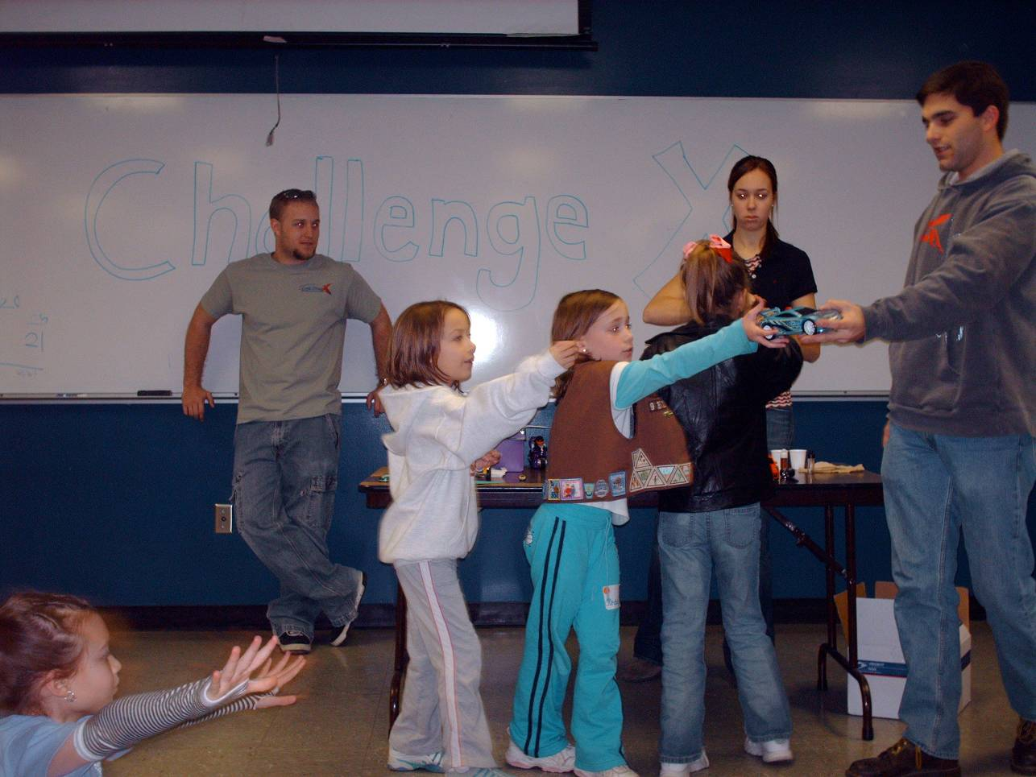

Team Leader Joshua Buck demonstrates one type of alternative fuel.

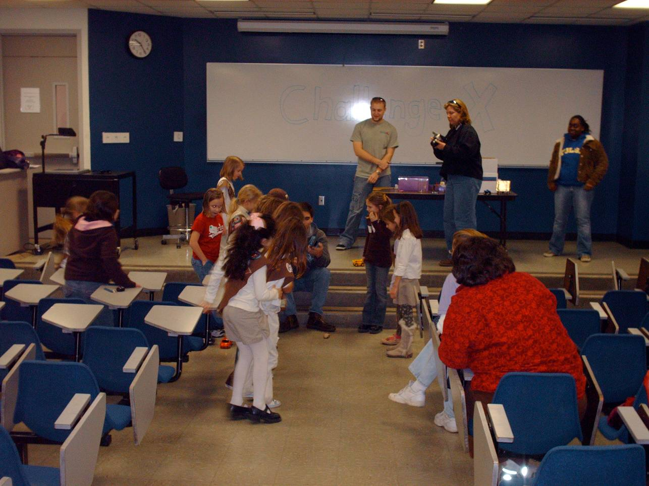
The girls line up to see the toy cars run.

2. Youth activity name: Middle School Open House Date/Time: 2/21/07 10a-3p
Location: Main Engineering Hall, University of Tulsa, Tulsa, OK
Team participants: Team Leader Joshua Buck, Outreach Coordinator Melissa Young, Team Members Clara Seaman and Michael Kennedy
Audience: Approximately 100 Middle School kids from the area
Activity description/details: Approximately 100 area middle school children came to visit the University and learn about the projects offered on campus. The Challenge X booth offered a tour of the Equinox, questions and answers with the team, and a game.
Key Messages Covered: What Challenge X is, who sponsors the team, and how Challenge X could help influence the market. Secondary topics of consideration were how to get involved with Challenge X and other alternative fueling options on campus.
Any measurable results: Handed out almost 40 brochures, involved several middle school students in the project. Educated students and parents on the event and the steps being taken towards alternative fuels.
Photos:

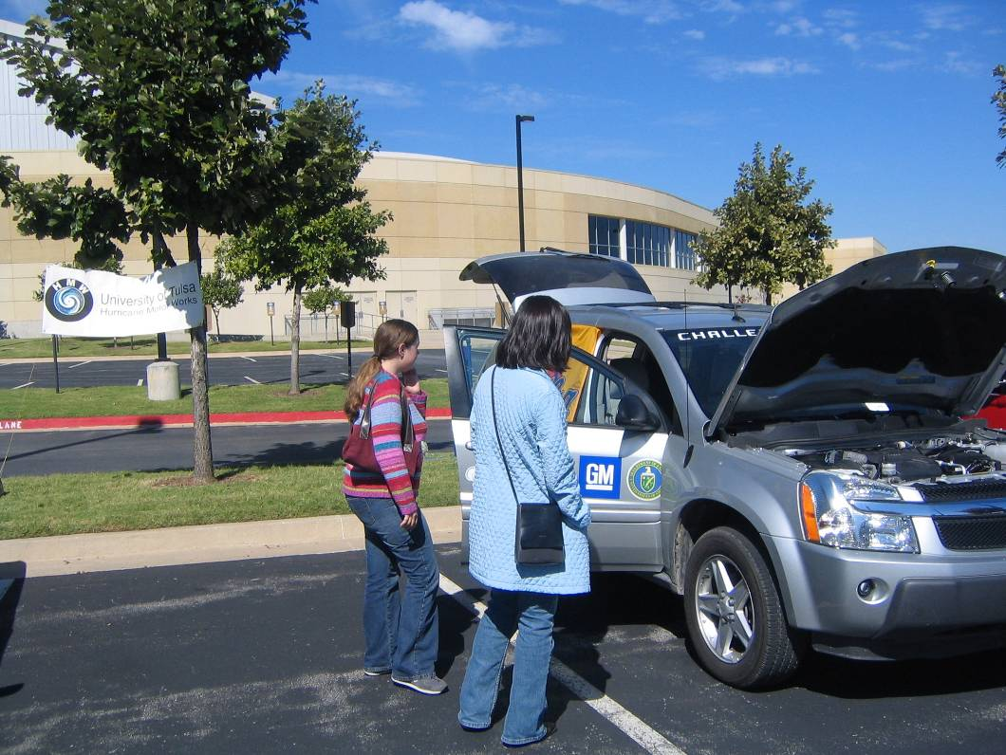
The car on display at TU

3. Youth activity name: Girl Scout Badge Day Date/Time: 2/24/07 8a-1p
Location: Main Engineering Hall, University of Tulsa, Tulsa, OK
Team participants: Team Leader Joshua Buck, Outreach Coordinator Melissa Young, Faculty Advisor Dr. Christi Patton
Audience: Approximately 65 local middle school and high school Girl Scouts
Activity description/details: The Challenge X Equinox sat on display with Challenge X team members who handed out fliers and answered questions about the car and the project.
Key Messages Covered: What Challenge X is, who sponsors the team, and how a student off campus can get involved.
Any measurable results: Handed out approximately 30 brochures, and interested several high school seniors in the University and the Project for the Fall.
Photos:
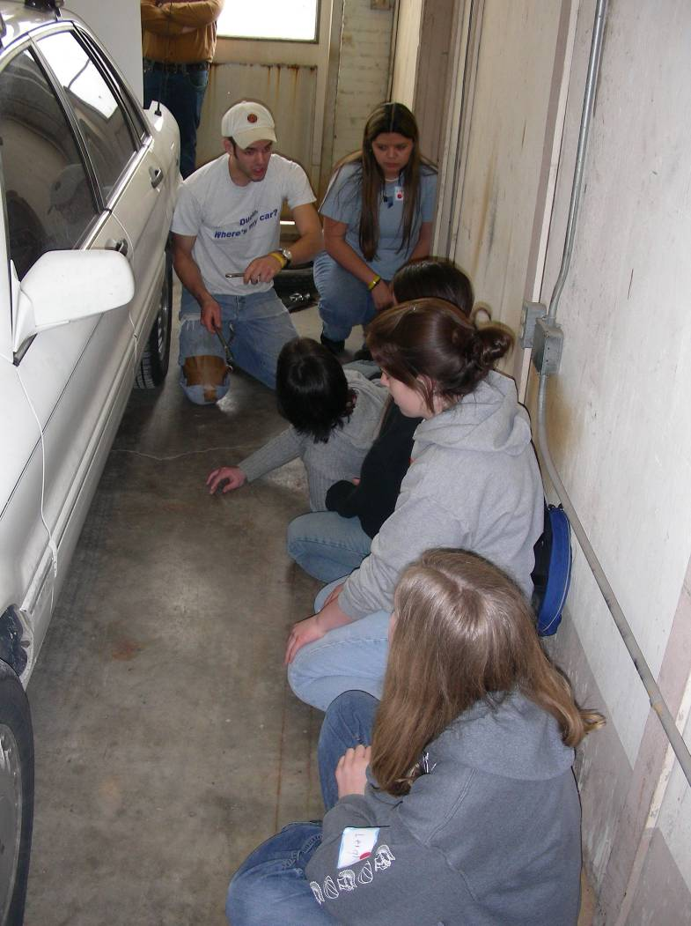
The girls learn their way around the Equinox

- Community Outreach (Requirement of 3 events)
Please use the chart to provide a list of all of your community outreach activities since your last outreach report. Also provide a written description below with additional details for each community outreach activity listed. Please number your events below.

Activity | Date | Location | Audience | Participants  (Briefly describe which team members participated)
1. Activities Fair | February 18, 2007 | Tulsa, Oklahoma | Prospective University of Tulsa Engineering Students (approx. 20) | Team Leader, Josh Buck; Outreach Coordinator, Melissa Young; Outreach Team Member, Sabrina Jones; Team Member, Adam Leeper
2. Seminar Presentation | February 26, 2007 | Tulsa, Oklahoma | Senior Chemistry Students at TU  (approx. 15) | Emissions Team Leader Clara Seaman, Faculty Advisor Dr. Christi Patton

1. Community event name: Activities Fair Date/Time: February 18
Location: Tulsa, OK The University of Tulsa Student Center
Team participants: Team Leader Josh Buck, Outreach Coordinator Melissa Young, Outreach Team Member Sabrina Jones and Team Member Adam Leeper
Audience: Prospective Engineering Students Approx. 20
Activity description/details: The Activities Fair is put on by the University of Tulsa in ordered to allow prospective students to learn about the many activities that are offered. The purpose of the Challenge X booth was to not only attract new members but to educate them about the project as a whole.
Key Messages Covered: The key message was to let the prospective students know that they too can become involved in Challenge X. We were able to interest the students in the project by speaking with them about the competition as well as allowing them to tour the car.
Any measurable results:
We recruited new members and we also raised awareness not only among prospective students but also among current students about Challenge X.
Photos:
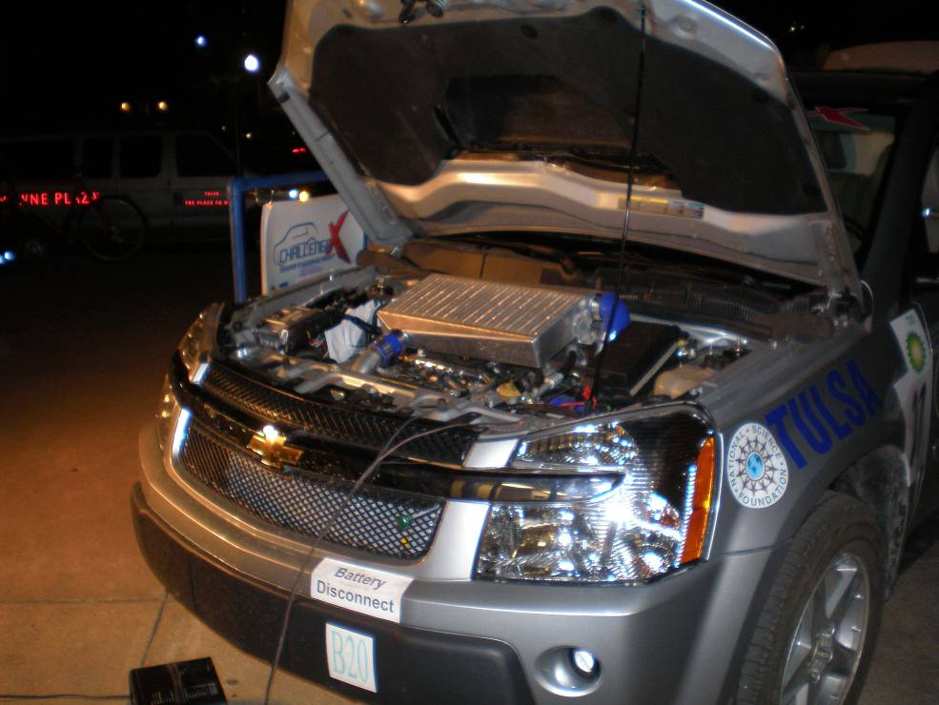
The car on display for students to tour.
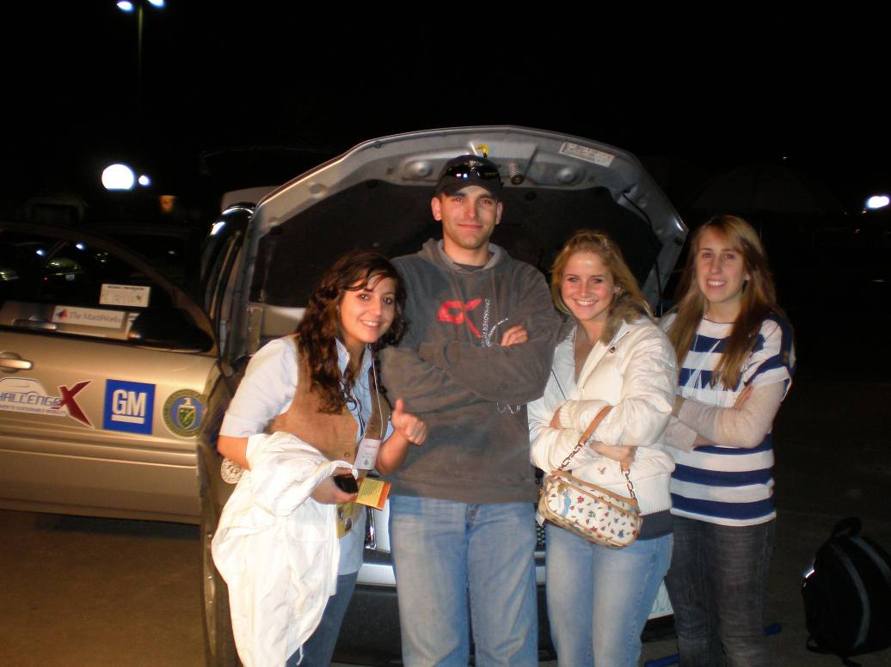
Several High School Seniors pose with the car and team leader Josh Buck

2. Community Event Name: Presentation for Senior Chemistry Seminar
Location: University of Tulsa, Main engineering hall
Date/Time: Feb 26, 2007
Team Participants: Clara Seaman
Audience: Seniors at TU, Approximately 12-15
Key Message: Clara gave a presentation about the Hydrogen System for the project.
Measurable Results: We collected some valuable input as far as hydrogen embrittlement from the upper level chemistry students, and raised awareness for the project.

- Sponsor Outreach (Requirement of 1 event)
Please use the chart to provide a list of your sponsor activities since your last outreach report. Also provide a written description below with additional details for each sponsor outreach activity listed. Please number your events below.

Activity | Date | Location | Audience | Participants  (Briefly describe which team members participated)

- Website
Please list any updates or modifications to your team’s website since your last outreach report, including:
- new additions in functionality
- new look/design
- special features
- Please include at least one screen grab of your team website below

In the past, TUCX has created online web games designed to educate and interest young students in alternative, fuel-efficient technology and more specifically, Challenge X. In Year One, TUCX created a game geared towards elementary aged children and in Year Two for middle schoolers. This year, TU’s Challenge X team is working to create a web game aimed for a High School audience. The game is not complete but will be finished by the end of the semester. In the mean time, a draft of the game is available at this site: www.hev.utulsa.edu/challengex/HybridHyjinx/
In this game, teens answer trivia questions to soup up a "fixer-upper". They periodically get their receipt for fuel consumption and earn cash to spend in the shop.
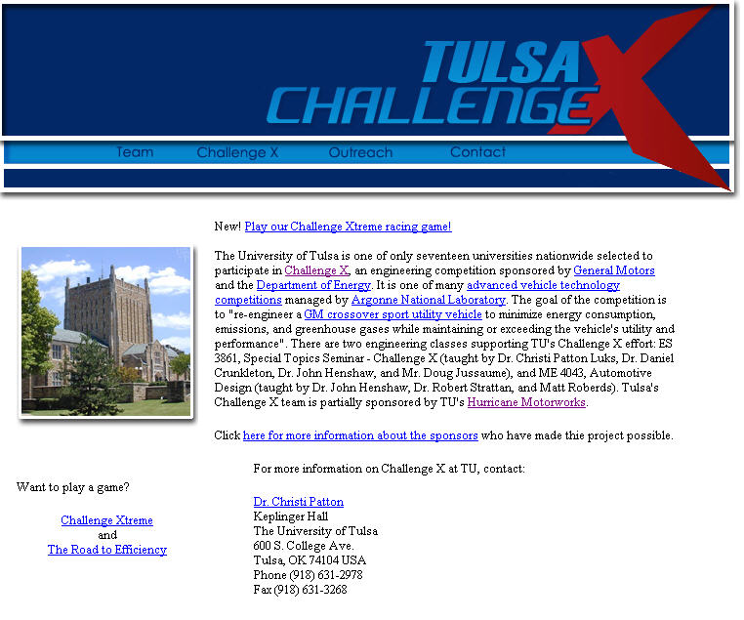
Tulsa Challenge X’s main homepage

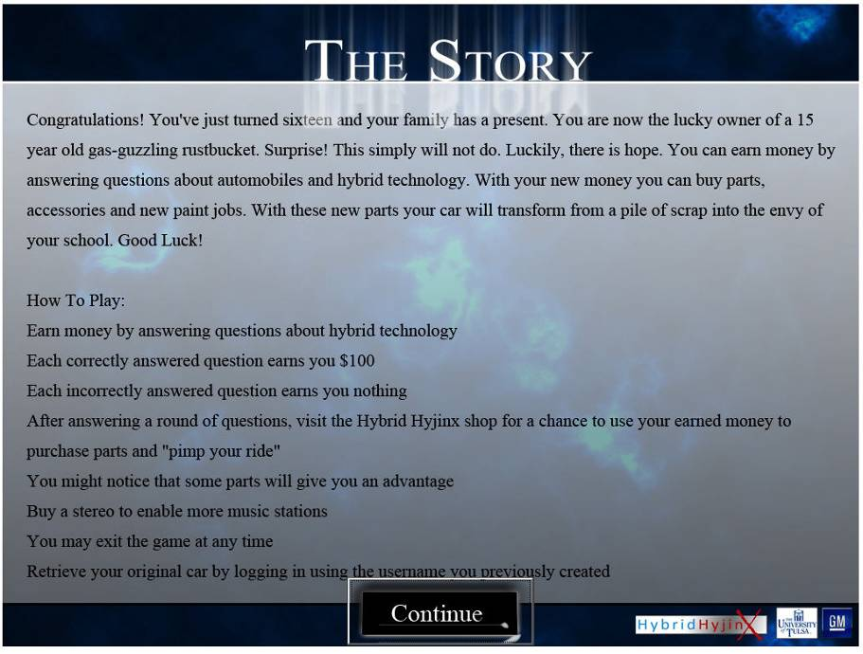
The game main page and description

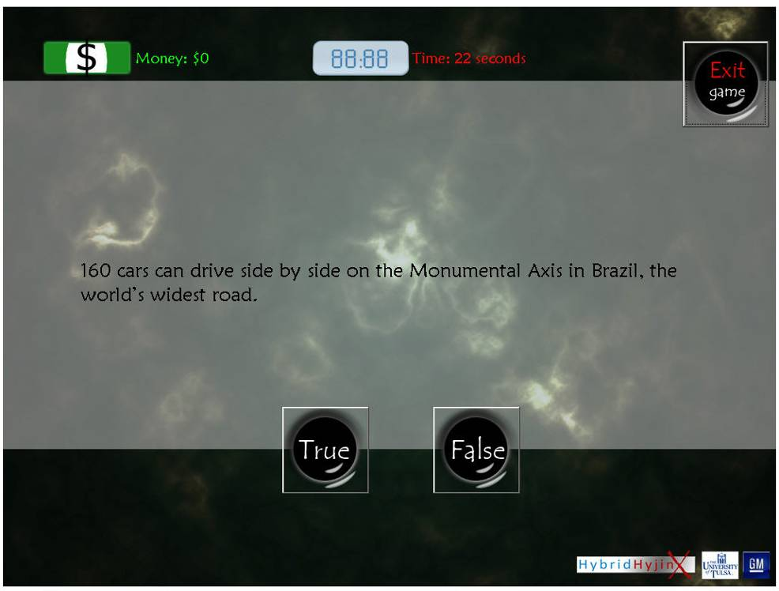
A sample question from the game

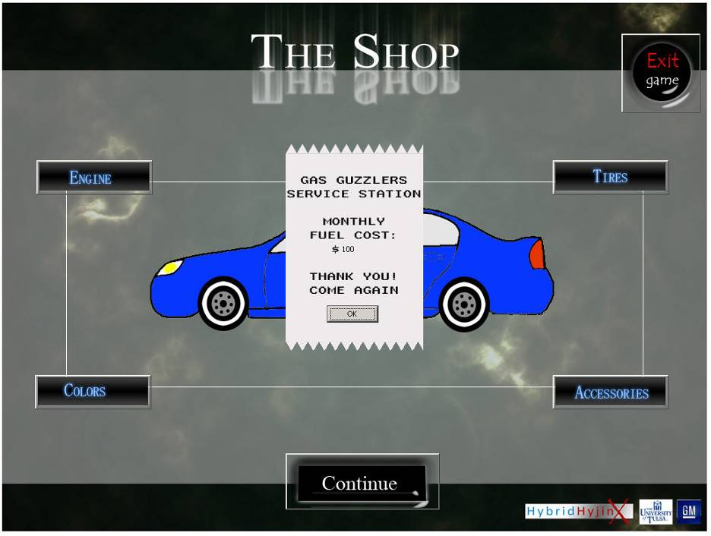
The car “shop” where the player can “buy” accessories

- Other

Please provide any other information on your team’s outreach program developments not covered above.

Reported by: Melissa Young Date: March 29th, 2007

Appendix: Copies of Media Clips

Please scan in or otherwise paste any clips of media coverage here.

